PROSPECTUS

NATIONAL EQUESTRIAN CHAMPIONSHIP - 2016
04, 05, 06 & 07 FEBRUARY 2016

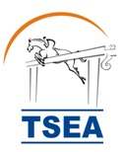

Organised by
TELANGANA STATE EQUESTRIAN ASSOCIATION
C/o. Hyderabad Polo & Riding Club
Aziz Nagar, Moinabad Road
Near Mrugavani National Park (Deer Park)
Hyderabad - 500 075, R.R. District



CONTACT
Phone: +91-40-65512222
Mobile: +91-9177000056
email: nec@hprc.co.in
NEC SHOW-JUMPING EVENT - 2016
04 Feb to 07 Feb 2016

TECHNICAL & ADMINISTRATIVE INSTRUCTIONS

General

1. The NEC Show-jumping 2016 will be conducted from 04 February 2016 to 07 February 2016 according to the Rules of the Equestrian Federation of India (EFI) by the Telangana State Equestrian Association (TSEA), Hyderabad.

2. The NEC Show-Jumping - 2016 events will be conducted on 04, 05, 06 & 07 February, 2016 at Hyderabad Polo & Riding Club (HPRC).

3. Venue: Route Chart of Hyderabad Polo & Riding Club is attached at Appendix 'A'

4. Schedule of Events and Technical Instructions: Refer Appendix 'B'.

5. Tentative Programme: Refer Appendix 'C'.

6. Entries:

(a) All entries will be on a proper Entry Form as given at Appendix 'D' and should be completed in all respects. Entries not on the prescribed entry form of without entry fee will not be considered.

(b) Entry Fee:

Individual Events: Rs.500/- per exhibit.

(c) Closing Date for Entries: Entries will close by 25 January, 2016. Entries received thereafter will be regarded as POST ENTRIES.

(d) Post Entries: Post entries will be accepted twenty four hours before the event. NO ENTRIES WILL BE ACCEPTED ON THE DAY OF THE EVENT. Post entry fee will be Rs.1,000/- per exhibit.

(e) Description and Registration of Horses: All entries must give the description, registration No. grading and name of the horse concerned. The name of the rider will be given for all classes.

(f) Payment: All entries must be paid in cash or by local cheque in favour of Telangana State Equestrian Association.
7. EFI Horses Passport:

(a) As per EFI rules all horses participating in the NEC 2016 events which are recognised by the EFI in their technical guidelines, i.e., Show Jumping have to be in possession of EFI Passport. No entries will be accepted without EFI Passport of horses and EFI registration. The Team Captains to be in possession of EFI Passports of horses during Veterinary Inspection.

(b) Team captains are requested to ensure that their horses are all registered before entries for the NEC 2016 are sent. The registration number has to be filled in the entry form as per EFI ruling. (contact EFI at 011-25683601).

8. EFI Rider Registration:

(a) ALL THE RIDERS OF 16 YEARS OF AGE AND ABOVE, PARTICIPTING IN THE EFI RECOGNISED EVENTS SHOULD OBTAIN EFI ID NO.

(b) RIDER WHO DOES NOT HAVE EFI RIDER ID NUMBER WILL NOT BE PERMITTED TO TAKE PART IN NEC 2016

9. Grading of Horses: It will be the responsibility of the riders/clubs/units to ensure that their horses are entered in the correct grade as per the latest updated list. Entry of the horse in the wrong grade will entail elimination from that event and disqualification from the entire horse show. If it is the last event that the horse is taking part in, then a fine of Rs.1,000/- will be deposited by concerned rider with the Secretary, Telangana State Equestrian Association before the horse leaves the camp, which will be forwarded to the EFI. Failure to deposit fee may entail disqualification from next event whenever wherever scheduled.

10. Withdrawal, Change, Transfer or Substitutions of Entry:

(a) Withdrawal: The Entry Fee of a horse entered for any event will not be refunded if the horse does not participate in the class.

(b) Transfer and Substitutions: A horse once entered in any event cannot be substituted by another horse for any reason whatsoever.

(c) Change of Riders: Riders cannot be changed unless the Jury accepts that there are sufficient reasons for change of riders. All changes will be treated as Post Entries. Once a class has started being judged, no change of rider will be accepted.

11. Cancellation: The events where upgradation of horses is involved, those events will be held irrespective of number of entries.
12. Reporting for Each Class: All horses will report to the Collecting Ring Steward half an hour before the time of judging of the class. Any entry not reporting in time will be eliminated unless the exhibitor shows good cause for the delay. The Ring Steward has full authority to take disciplinary action.

13. Show Number: All horses will display the EFI Registration Number on the bridle during completion and veterinary inspection and whenever taken out of the stable under the saddle.

14. All events scheduled in the afternoons will continue under lights, when required.

15. Abuse / Cruelty to Horses: Refer to Article 212 of EFI Technical Guidelines 2013.

16. Elimination/Disqualification: The judges are empowered to disqualify the competitors at any stage of the competition for rough handling, excessive brutality or any form of cruelty to animals. Rapping will be severely penalised. Refer to Article 243 FEI Rules for Jumping Events 2015.
17. Whips/Spurs: As per EFI and relevant FEI rules per discipline.

18. Dress Code: When inspecting the course, dress must be neat and tidy. In any case, riding boots, white breeches, a white or lightly coloured plain shirt, white tie and Jacket must be worn. Service personnel will be in uniform. It is compulsory for anyone jumping a horse to wear properly fastened hard hat with three point retention harness including riders in uniform.

19. Appeal: Appeal can be lodged by competitors within two hours before the commencement of any class and within half an hour after announcement of the result. A fee of Rs.2000/- (Rupees Two Thousand Only) should be deposited with the Secretary, Telangana State Equestrian Association alongwith the objection. Money will be refunded if the objection is upheld.

20. Certificates will be given only upto 3rd place and medals will be given upto 3 places.

21. Medical Cover: The Organising Committee will provide medical cover for riders at the venue. The Organising Committee shall not accept any liability for medical treatment given to a player on the venue or the consequences thereof. The Organising Committee will only provide first aid emergency treatment as well as evacuation to the hospital where necessary, though every possible available medical cover will be presented.

22. Insurance: The Organising Committee recommends units/clubs/associations to take insurance policies for competitors, personnel, grooms and horses during the events. The Organising Committee will assume no responsibility for any accident or illness due to fall of any horse, competitors, grooms/any other member of the team.
23. Responsibility: The Organising Committee accepts no responsibility for any loss, damage or injury to any animal or any other property or the exhibitors themselves. neither the Committee not the Doctor will be held responsible for any first aid or other medical treatment provided.

24. Camping and Accommodation:

i) The camp opens on 29th January, 2016 and closes on 10th February, 2016.
ii) All teams should come fully equipped with their own tentage for stabling and enough grain and fodder for the duration of the show.
iii) The Organisers will try to arrange for Bedding straw and fodder to be made available for sale at retail prices.
iv) All teams that require stables must send their requirements before the 15th of January, 2016, after which no stable orders can be accepted.
v) The cost of one temporary stable will be Rs.3500/- for the duration of the show.
vi) All teams must inform the organisers of their total strength (personnel and animals) by the 27th of January, 2016, so that camp sites of appropriate size can be allocated for all teams, both civilian and government.
vii) All teams must inform the organisers of their estimated time of arrival well in advance.
viii) Any teams requiring a horse float and/or a vehicle to transport luggage from the Nampally (Hyderabad) Railway Station to the Hyderabad Polo & Riding Club (HPRC) must inform the Organisers by 25th January, 2016, to facilitate reservation of floats/trucks.
ix) The cost of transporting six horses from the railway station to HPRC by horse float is Rs.2500/-.
x) All bio-degradable waste including horse dung is to be put into the pits provided.
xi) No open fires are permitted on Hyderabad Polo & Riding Club (HPRC) grounds.

24a) Accommodation:

i) Accommodation for participants will be available on payment basis at Sardar Vallabai Patel National Police Academy Officers Mess, which is located on the Hyderabad-Bangalore Highway about 12 kms away from the venue (HPRC).
ii) Accommodation will also be available at Andhra Pradesh Police Academy Officers Mess, which is about 2 kms away from the venue.
iii) 4-Star accommodation will be available at Mrugavani Resort & Spa, which is located right next to the venue. The Tariff is enclosed with the Prospectus. The owners of the property have agreed to extend 30% discounts to the participants.
The rooms will be available on first come first serve basis; participants are requested to make a request to the organisers well in advance for booking the rooms.

25. Self Containment: All teams coming to participate in the Horse Show must be self- contained, i.e., they should bring their own tentage, equipment for camping, cooks and transport, etc. Any contingent requiring camping stables at the premises may contact the Secretary, Telangana State Equestrian Association (TSEA), by 20th January, 2016.

26. Ration/Fodder: Army contingents are advised to bring maximum quantity of grain/fodder to sustain their horses during their stay in Hyderabad or they can ask for attachment with the local Supply Depot. Other contingents are advised to make their own arrangements for animal rations. However, animal rations and hay can be procured on cash payment.

27. Coggin's and Glanders Tests: All rules and instructions issued from the EFI and Remount Veterinary Directorate, Army Headquarters on the subject will be strictly adhered to by all concerned. All horses must produce a valid negative EIA and Glander status certificate on arrival to Hyderabad. Coggin's and Glanders negative certificate with a validity of a minimum of 15 days on arrival and exit of horses from the camp is mandatory.

28. Veterinary Commission: The Veterinary Commission detailed by office of NEC 2016 at Hyderabad will have full right to examine all the horses participating.

29. Veterinary Assistance:

A Veterinary First Aid Hospital will be established at the Camp Site for Treatment.

30. Article 206 of EFI
Eligibility of Riders:

(a) All riders of 16 years and above can participate.
(b) A rider can enter a maximum of three horses in each grade. he will have to nominate any two horses for his penalties to be counted towards rider points, nominated horses will start first in the competition.
i) If a rider does not nominate his horse before the start of the competition, then the first horse ridden in the competition will be deemed as nominated horse and penalties accrued by first horse ridden will count.

31. Article 207 of EFI
Eligibility of Horses by Age

(a) All horses of 4 years of age and above can participate in Preliminary Jumping unless upgraded.
(b) All horses of 5 years of age and above can participate in Novice and Grade III Jumping.

(c) All horses of 6 years of age and above can participate in Grade II and Grade I, however for Grand Prix the minimum age of horses will be 7 years.
32. Article 202 of EFI
Standards for Jumping Competitions:
(Min 66% of the jumps will be of full height and spread to include three vertical and three parallel jumps. Mandatory to have two round competitions in NEC & EFI approved competitions)
Grade | Height |  | Spread  Max | Speed  Per Min | No. of  Rounds | No. of Jumps
Grade | Min | Max
PRELIMINARY  (Only at Regional  Shows) | 0.90 | 1.05 | 1.20 | 325 M | Two | Max 14 obstacles. No combination.
NOVICE | 1.00 | 1.10 | 1.25 | 350 M | Two | Max 14 obstacles. One double combination in each round.
GRADE III/Medium | 1.10 | 1.20 | 1.40 | 350 M | Two | Max 14 obstacles with one triple and one double combination or three double combinations in each round.
GRADE II/  Intermediate | 1.20 | 1.30 | 1.50 | 350 M | Two | Max 14 obstacles with one triple and one double combination or three double combinations in each round.
GRADE I/Advance | 1.30 | 1.40 | 1.60 | 375 M | Two | Max 14 obstacles with one triple and one double combination or three double combinations in each round.
Grand Pix | 1.35 | 1.50 | 1.70 | 375 M | Two | -do-
Top Score Competitions Max height of JOKER will not be more than 15 cm higher than the maximum height of that grade.
The JOKER will compulsorily be a VERTICAL fence.

33. Article 207 A
The competitive participation will be followed as defined below (as amended 2015)

a) | Novice to GD III | Novice grade horse can participate competitive upto Gd III provided the horse incurs maximum 8 penalties in novice jumping over two rounds competition / 4 jumping fault on one round competition. However, if a Novice Gd horse comes in first three medal positions of Gd-III Jumping, then the horse will stay in Gd-III.
b) | GD III to GD II | Grade III horse can participate competitive upto Gd II provided the horse incurs maximum 8 penalties in Gd III jumping over two rounds competition / 4 penalties in Gd III jumping over one round competition. However, if a Gd-III horse comes in first three medal positions of Gd-II jumping, then the horse will stay in Gd-II.
c) | GD II to GD I | Grade II horse can participate competition upto Gd I. However, if a Gd-II horse comes in first three medal positions of Gd-I jumping, then the horse will stay in Gd-I.
d) | GD I & GD II to Grand Prix | Grade I & Grade II horses can participate competitive upto grand prix.
34. Correspondence: All correspondence in respect of the NEC 2016 will be addressed to:

The Secretary
Telangana State Equestrian Association
C/o. Hyderabad Polo & Riding Club
Aziz Nagar
Moinabad Road
Near Mrugavani National Park (Deer Park)
Hyderabad 500075
email: nec@hprc.co.in
Phone: +91-40-65512222
Mobile: +91-40-9177000056

35. Note: The Organising Committee, may at any time alter/amend any of the above conditions, owing to unforeseen circumstances.

Sd/-
Secretary
TSEA

Distribution:

All Clubs/School/Units
Appendix 'A'
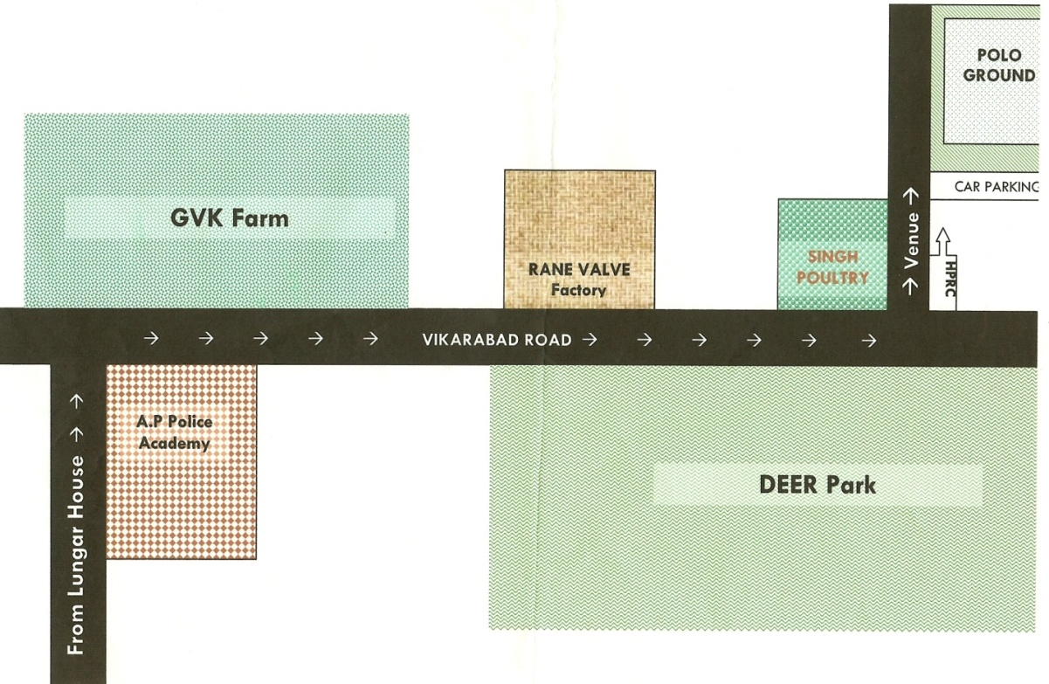
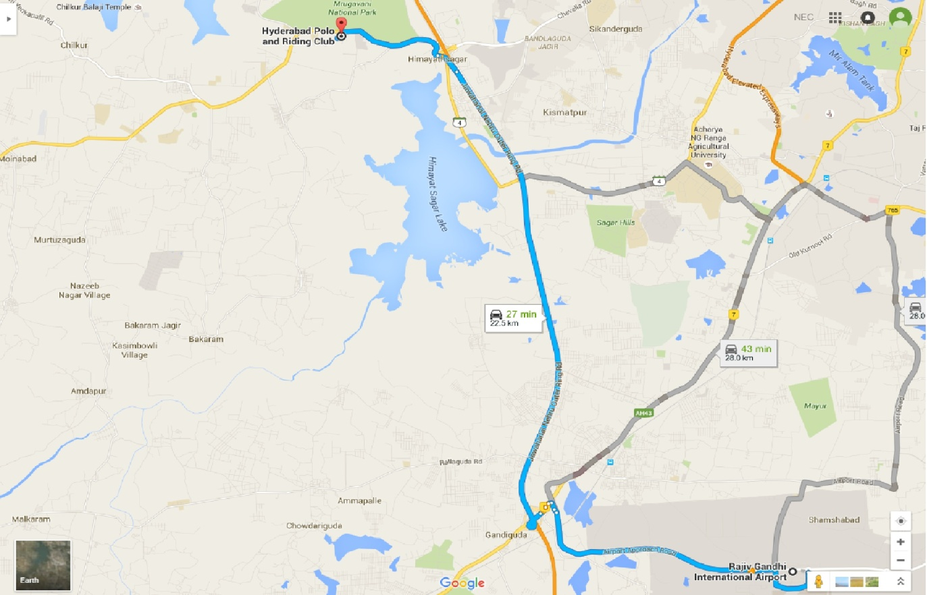https://www.google.co.in/maps/dir/Rajiv+Gandhi+International+Airport,+Hyderabad,+Telangana/Hyderabad+Polo+and+Riding+Club,+Hyderabad,+Telangana/@17.2970467,78.3636148,13.25z/data=!4m13!4m12!1m5!1m1!1s0x3bcbbb7fb1d91b45:0x532029ec33eaa851!2m2!1d78.4293851!2d17.2402633!1m5!1m1!1s0x3bcb95a08aec4bdd:0x7771790edea5a94e!2m2!1d78.3393168!2d17.3525987
Appendix 'B'

SCHEDULE OF EVENTS
NATIONAL EQUESTRIAN CHAMPIONSHIPS - 2016
JUMPING

S.No. | Category | Remarks
1 | Preliminary Jumping | Non NEC Event
2 | NEC Novice Grade | Open to Novice Horses Only. Jump specifications as per EFI Technical Guidelines 2013
3 | NEC Grade III / Medium Grade | Open to Grade III Horses only. Jump specifications as per EFI Tech. Guidelines 2013
4 | NEC Grade II / Intermediate Grade | Open to Grade II Horses only. Jump specifications as per EFI Tech. Guidelines 2013
5 | NEC Grade I / Advanced Grade | Open to Grade I Horses only. Jump specifications as per EFI Tech. Guidelines 2013
6 | NEC Grand Prix | Open to Grade II and Grade I horses. As per EFI Tech. Guidelines 2013
7 | Grade III Jumping Top Score | Open to Grade III Horses only. As per FEI Rules
8 | Novice Grade Accumulator Jumping | Open to Grade Novice Horses only. As per FEI Rules
9 | Six Bar Jumping | Open to Grade II and Grade I horses. As per FEI Rules
10 | Fault and Out Jumping | Open to Novice Horses only
11 | Puissance | Open to Grade II and Grade I horses. As per FEI Rules

Appendix 'C'

TENTATIVE PROGRAMME

3rd February, 2016, Wednesday

Time | Name of Event | Venue
1000 hrs | Veterinary Inspection | Training Area

4th February, 2016, Thursday

Time | Name of Event | Venue
1000 hrs | Preliminary Jumping Round 'A' (Non-NEC) | Jumping Arena
1200 hrs | Novice Jumping Round 'A' | Jumping Arena
1400 hrs | Preliminary Jumping Round 'B' (Non-NEC) | Jumping Arena
1600 hrs | Novice Jumping Round 'B' | Jumping Arena

5th February, 2016, Friday

Time | Name of Event | Venue
1000 hrs | Grade III Normal Jumping Round 'A' | Jumping Arena
1200 hrs | Novice Accumulator Jumping | Jumping Arena
1400 hrs | Grade III Normal Jumping - Round 'B' | Jumping Arena
1800 hrs | Fault and out for Novice horses | Jumping Arena

6th February, 2016, Saturday

Time | Name of Event | Venue
1000 hrs | Grade II Normal Jumping Round 'A' | Jumping Arena
1330 hrs | Grade II Normal Jumping Round 'B' | Jumping Arena
1600 hrs | Grand Prix Jumping - Round 'A' | Jumping Arena
1800 hrs | Grand Prix Jumping - Round 'B' | Jumping Arena
1900 hrs | Six Bar - Open to Gd II & Gd I | Jumping Arena

7th February, 2016, Sunday

Time | Name of Event | Venue
1000 hrs | Grade I Normal Jumping Round 'A' | Jumping Arena
1300 hrs | Grade I Normal Jumping Round 'B' | Jumping Arena
1700 hrs | Top Score for Gd III Horses | Jumping Arena
1830 hrs | Puissance for Gd II and Gd I Horses | Jumping Arena

ENTRY FORM
NATIONAL EQUESTRIAN CHAMPIONSHIPS - 2016
Name of Unit/Individual: Appendix ‘D’
Sl.  No | Event | Rider |  |  | Entry |  |  |  |  |  | Entry  Fee | Remarks
Sl.  No | Event | Name | EFI ID  No. | DOB | Name of  Horse | EFI  Regn No. | Passport No. | Colour | Sex | Age in year | Entry  Fee | Remarks
 |  |  |  |  |  |  | Total Fee
Mobile No. _______________________
Note: Entries will not be accepted without EFI No./Passport No. and Rider ID No.

